ANALYZING SMART CITY BIKE SHARING DATA USING POWER BI

PROJECT OVERVIEW:
- Urban transportation is changing rapidly across the world. With increasing traffic, pollution, and fuel costs, many cities are promoting eco-friendly transportation systems. One of the most successful systems is Bike Sharing.Bike Sharing is a service where users can rent a bicycle from one station and return it to another station. It is cheap, healthy, and environment-friendly. In France, cities like Marseille, Nantes, and Nancy have implemented a well-structured bike sharing system.However, managing hundreds of stations is not easy. City authorities need to know: Which station has bikes? Which station is empty? Which city needs more stations? To answer these questions, data visualization is needed.VeloVista is a Power BI dashboard created to solve this problem. It converts raw bike station data into simple, interactive visuals that anyone can understand.2. Problem Statement
- The bike sharing system generates a large amount of data every day. Without proper visualization, this data is difficult to understand.The main problems are:Authorities cannot easily identify stations with zero bikes.There is no clear comparison between cities.It is difficult to track how many stations are OPEN or CLOSED.Bike redistribution is not planned properly because of lack of insights.This project aims to solve these problems by creating a clear and interactive dashboard.The dataset used in this project is named Bike Sharing Raw Data.
DATA SOURCE:
Domain:Analysing Smart City Bike Sharing Data Using Power BI
PROBLEM STATEMENT:
- The Bike Sharing System in France generates a large amount of station data every day. This data is stored in raw Excel format, which is difficult to understand and analyze.
- City authorities face problems in identifying empty stations with zero bikes, full stations with zero stands, and CLOSED stations. There is also no clear comparison between the cities Marseille, Nantes, and Nancy.
- Without a proper visual system, bike redistribution planning becomes slow and inefficient, which leads to poor user experience.Therefore, there is a need for an interactive Power BI dashboard that converts raw data into simple visuals to monitor stations, track bike availability, and support quick decision-making.
ATTRIBUTE COLUMN:
S.No | Column Name | Data Type | Description
1 | City | Text | Name of the city - Marseille, Nantes, Nancy
2 | Station ID | Number | Unique ID for each bike station
3 | Station Name | Text | Name of the bike station
4 | Available Bikes | Number | Number of bikes available for rent at the station
5 | Available Stands | Number | Number of empty stands available to return a bike
6 | Status | Text | Station status - OPEN or CLOSED
7 | Lattitude | Number | Geographical latitude of the station location
8 | Longitude | Number | Geographical longitude of the station location
TOOLS & TECHNOLOGIES:
Power BI: Data modelling, DAX calculations, visualization, and interactive dashboard creation.
TASK PERFORMED:
1. Microsoft Excel
Used for data collection, cleaning and storing raw bike sharing data
.2. Power BI Desktop
Used for data visualization and creating interactive dashboard.
3. Power Query
Used for data cleaning, removing duplicates and transforming data.
4. DAX - Data Analysis Expressions
Used for creating measures like Total Stations, Total Bikes and Total Stands.
5. Microsoft Word
Used for preparing project documentation and report.
6. Microsoft PowerPoint
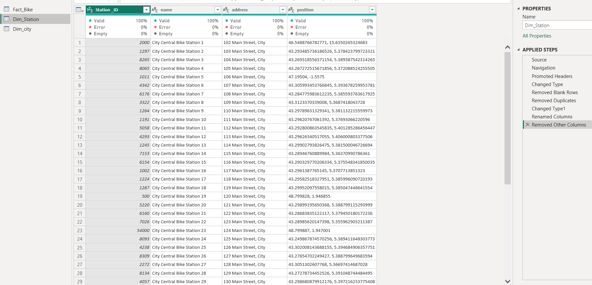 Used for preparing presentation for viva and demo.Why Power BI is Used:
Power BI converts large raw data into simple charts, maps and KPI cards. It is interactive, easy to use and helps in quick decision making.

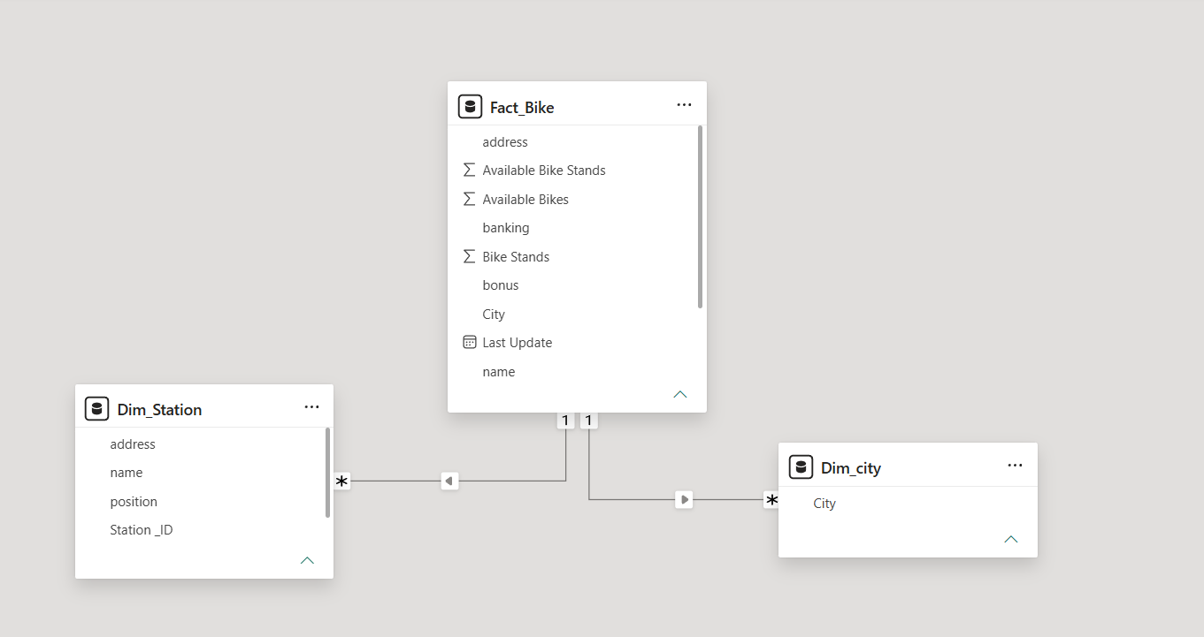
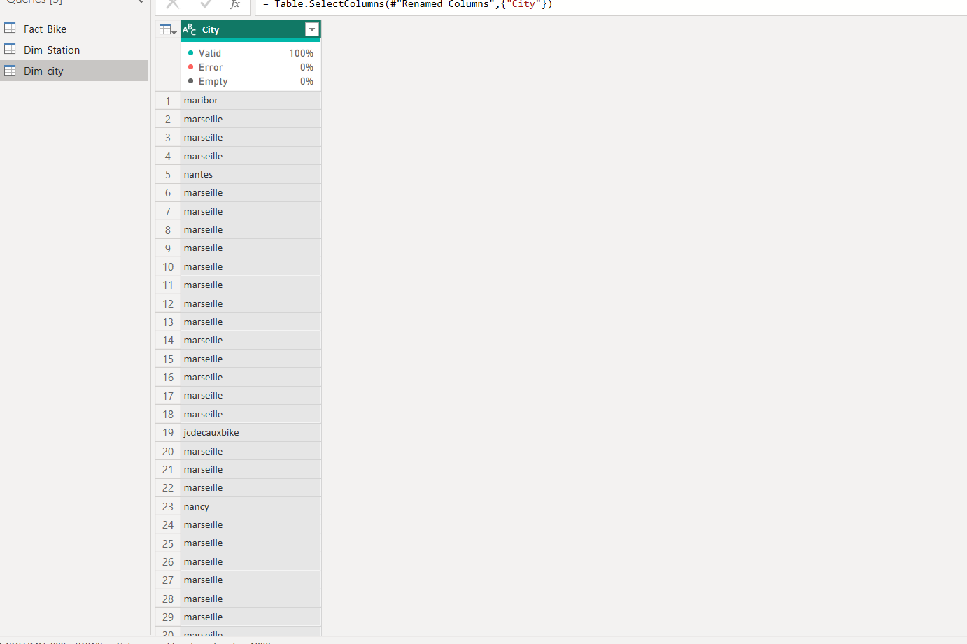
DAX CALULATION:
- Total Stations = COUNTROWS( BikeData )
- Total Bikes = SUM( BikeData[Available Bikes] )
- Total Stands = SUM( BikeData[Available Stands] )
- Empty Stations = CALCULATE( COUNTROWS( BikeData ), BikeData[Available Bikes] = 0 ) 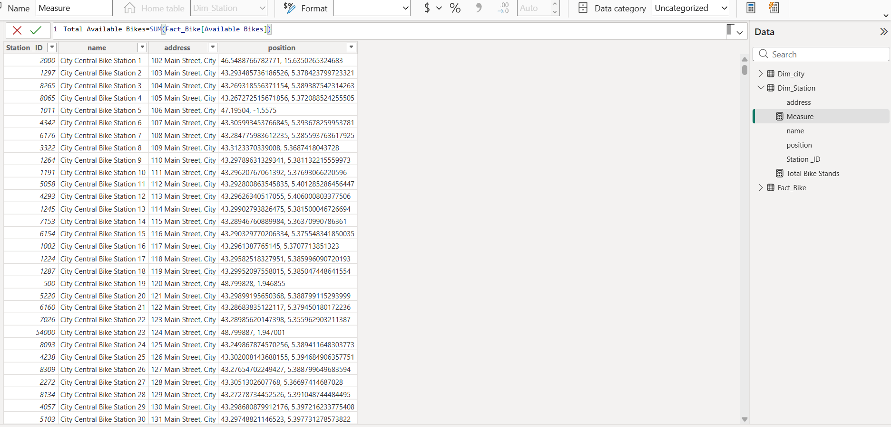
ANALYSIS AND VISUALIZATION (Power BI):
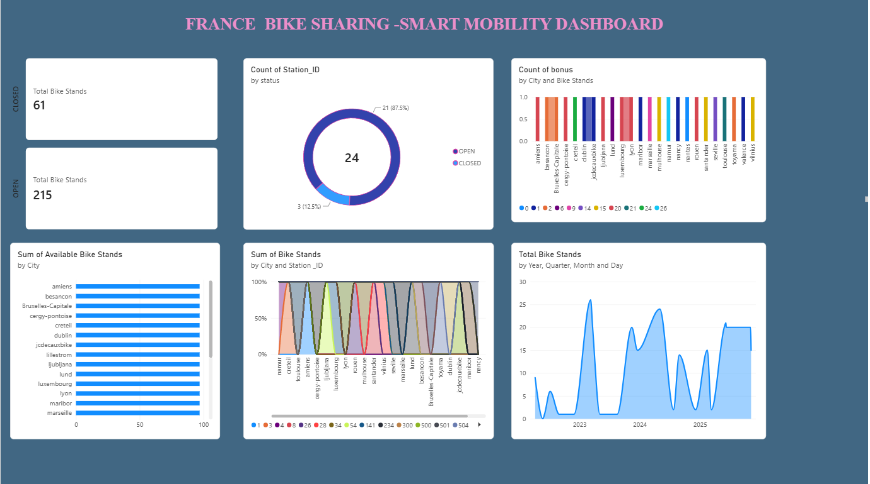

FOUR TYPES OF ANALYTICS
1. Descriptive Analytics - What Happened?
This shows what already happened in the bike sharing system.
Example: Total Stations, Total Bikes, Total Stands in Marseille, Nantes and Nancy. City-wise bar chart shows which city has more stations.
2. Diagnostic Analytics - Why Did It Happen?
This finds the reason for a problem.
Example: Why some stations have zero bikes? Because bikes were not redistributed on time. Why some stations are CLOSED? Because of maintenance and technical issues.
3. Predictive Analytics - What Will Happen?
This predicts what may happen in future based on past data.
Example: Stations which become empty frequently in peak hours may become empty again. More bikes will be needed in Marseille because it has highest demand.
4. Prescriptive Analytics - What Should We Do?
This suggests what action to take.
Example: Move bikes from full stations to empty stations. Open more stations in areas with high demand. Repair CLOSED stations quickly to improve user satisfaction.
CONCLUSION:
The Bike Sharing Dashboard project successfully converts raw Excel data from Marseille, Nantes and Nancy into a simple and interactive Power BI dashboard.From this dashboard, it is clearly understood which city has more stations, where bikes are available, and which stations are empty, full or CLOSED. This helps authorities to take quick decisions for bike redistribution and station maintenance.The dashboard also helps to improve user satisfaction because users can easily find a station with available bikes and stands. It reduces time taken for manual analysis and reporting.Overall, this project proves that Power BI is a powerful tool for data visualization and decision making. In future, this dashboard can be improved by adding real-time data, user demand prediction and weather-based analysis.

